[**Back to HCI Lab Home Page**](http://iitg.vlab.co.in/?sub=72&brch=170)

**Fitts’s Law - Modeling Target Movement Time in HCI**

**Fitts's law** is a model of speed-accuracy tradeoffs used in human–computer interaction and ergonomics. It  predicts time required to acquire a target on screen as a function of the distance to the target and the size of the target. Fitts's law is used to model the act of *pointing*, either by physically touching an object with a hand,finger or virtually  or  by pointing to an object on a computer monitor using a pointing device. It was proposed by Paul Fitts in 1954. *(Reference: http://en.wikipedia.org/wiki/Fitts%27s_law)*

Mathematically it can be written as

MT = a + b log 2 ( 2A / W )

MT : Movement time (average) taken to complete the movement or point the target

   a  : Start / Stop time of the device (y intercept)

   b  : Inherent speed of the device (slope of line)

  W : Width of the target measured along the axis of motion, which corresponds to accuracy

   A : Distance from the starting point to the center of the target

The term **log 2 ( 2A / W )**  is called the **index of difficulty (ID)**. It describes  the  difficulty of the motor tasks.  1/b is  also called the **index of performance (IP)**  and measures the information capacity of the human motor system.

Thus  MT= a+b ID = (a + ID) / IP

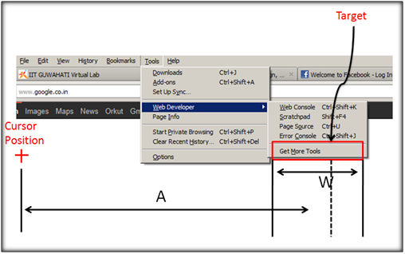 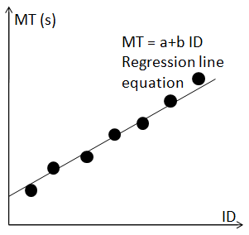

**Physical interpretation and application of Fitts’s Law**

* Big targets at close distance are acquired faster than small targets at long range.
* arget  acquiring difficulty increases by one unit for each doubling of  distance  and halving of width  of  target.
* Fitts's Law can be used  to evaluate  alternative interaction methods in Graphical User Interface (GUI).
* It can also be used to predict the performance of operators in user-adaptive systems.

*(Reference:  http://www.cs.umd.edu/class/fall2002/cmsc838s/tichi/fitts.html)*

**Use of Fitts’s Law to radial menus**

Supposing a designer is confronted with choosing between a linear array type of menu and a round menu in which control buttons are placed radially. Fitts law helps the designer in finding out which would be functionally more efficient and error free given the use context.

Also the advantage of radial menus can be demonstrated with Fitts’s Law. Since menus pop up at the current cursor position and all items are at same distance from the centre, they can be approximately reached at the same speed in addition pointing is enhanced as the radial slices are of infinite size and thus can be more quickly and reliably selected. *(Reference : http://www.betriebsraum.de/blog/2009/12/11/extremely-efficient-menu-selection-marking-menus-for-the-flash-platform/)*

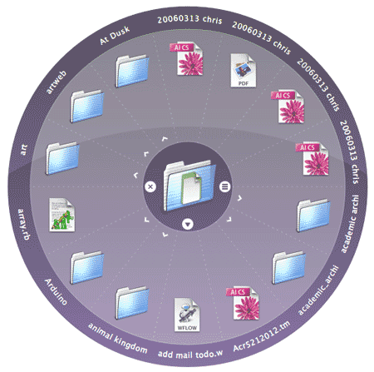

It should be noted that while Fitts’s law applies to the physical movement of the pointing devices, other human factors like search-time and decision-time for item selection, must also be taken into account when evaluating the overall performance of menu systems.

  To proceed  further  click on the **OBJECTIVE** tab on the top or to exit this experiment  click on **HOME**  on the top.

# [Back to HCI Lab Home Page](http://iitg.vlab.co.in/?sub=72&brch=170)

**After performing this experiment**

1.     You will observe the effect of target distance and target size on the GUI target selection time.

2.     You can apply fitt's law in designing and placing widgets on computer interface.

 To proceed  further  click on the **PROCEDURE** tab on the top or to exit this experiment  click on **HOME**  on the top.

# [Back to HCI Lab Home Page](http://iitg.vlab.co.in/?sub=72&brch=170)

1.     Be alert. You will see a circle displayed on the screen.

2.     You will have to click on the circle the very moment it appears.

3.     Once you click the first circle, another circle with random size, color  and  position will appear on the screen.

4.     Click on this next circle too the very moment you see it.

5.     Repeat steps 3 and 4 as long as circles continue to appear. ( around 21 circles )

6.     Finally you will see a table having data of your selection time, target distances to circle and circle dimensions.

7.     Observe the graph carefully and  analyse  the  results.

 To proceed  further  click on the **SIMULATOR** tab on the top or to exit this experiment  click on **HOME**  on the top.

# [Back to HCI Lab Home Page](http://iitg.vlab.co.in/?sub=72&brch=170)

1.     Can  you see a circle displayed  on the screen  below?

2.     Click on this circle the moment you see it.

3.     Another circle with random size, color and position will appear on the screen.

4.     Click on this next circle the moment you see it.

5.     Repeat steps 3 and 4 as long as circles are displayed. ( around 21 circles  )

6.     Finally you will see the recorded data of selection time , target distances and circle dimensions.

7.   Observe the graph carefully and take a screenshot of the graph and the table and save it on your computer for later use as instructed under assignment tab.

http://iitg.vlab.co.in/fckeditor/editor/images/spacer.gif

 To proceed  further  click on the **QUIZ** tab on the top or to exit this experiment  click on **HOME**  on the top.

# [Back to HCI Lab Home Page](http://iitg.vlab.co.in/?sub=72&brch=170)

1.     What is the significance of coefficient a and b in the mathematical expression of fitts’s law?

2.     What inference can you draw from the graph presented at the end of  the experiment?

3.     Using the interaction data of  the experiment  try to plot a graph of ***ID Vs MT*** and find its slope. Is the slope same for different individuals?

 

 To proceed  further  click on the **ASSIGNMENT** tab on the top or to exit this experiment  click on **HOME**  on the top.

# [Back to HCI Lab Home Page](http://iitg.vlab.co.in/?sub=72&brch=170)

1.   Using the screenshot of graph and table saved by you plot a graph with diameter of target along x-axis and corresponding selection time on y-axis. You will see an inverse relationship between the diameter of the target and the selection time.

2.  Perform the same experiment using a touchpad on a laptop instead of the mouse. Will use of touchpad on the laptop increase or decrease the target selection difficulty or the slope of the line? Compare your results and graphs.

3.   You can repeat the same with a touch screen if available. Compare your results and graphs.

 To proceed  further  click on the **REFERENCE** tab on the top or to exit this experiment  click on **HOME**  on the top.

# [Back to HCI Lab Home Page](http://iitg.vlab.co.in/?sub=72&brch=170)

**URLs**

( as on 26 January 2012 )

http://en.wikipedia.org/wiki/Fitts’s_law

http://www.slideshare.net/lrizoli/fitts-law-basics

http://en.wikipedia.org/wiki/Pie_menu

http://msdn.microsoft.com/en-us/library/ms993291.aspx

http://en.wikipedia.org/wiki/Point_and_click

http://en.wikipedia.org/wiki/Human-computer_interaction

  To give feedback  for this experiment click on the **FEEDBACK** tab on the top or to exit this experiment click on **HOME**  on the top.